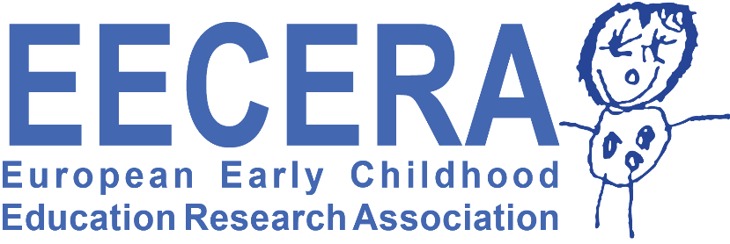
EECERA Conference Delegate Welcome Message
From EECERA President: Professor Chris Pascal
Dear EECERA conference delegates,
I am super excited to be meeting up with you all face to face in Glasgow at the end of August. We have had wonderful online conference events for the last 2 years which have kept our EECERA community connected but it is my hope that our in-person meeting in Glasgow will allow for more spontaneous, creative and lively dialogues! Glasgow will be an amazing place for us to reconnect and we are preparing to welcome EECERA delegates from all over the world, both old friends and new.
These last three years have been relentless in the challenges we have all been faced with – the COVID pandemic, climate change, economic downturn, population displacements on a massive scale and, perhaps most shocking, war within Europe. These shocks bring exceptional challenges for every one of us which will need our solidarity, collective action, partnerships and importantly, honest critical dialogues with each other if we are to progress.
EECERA unequivocally condemns the invasion of Ukraine by the Russian Government and we want to express our absolute solidarity and support for Ukrainian universities, scholars, teachers and students. Following guidance from Universities UK, we have reviewed our current Russian research links and projects, and decided that we should not pursue a blanket boycott for Russian colleagues at our conference. We believe this would undermine Russian scholars, academics and students who have participated in our EECERA research community over many years, and some of whom have condemned the invasion at great personal risk. We think that critical and rigorous dialogue, collaboration and research across all divides are vital if we are to address these global challenges and create a more peaceable world.
So, when we gather in Glasgow we trust that as a community of international scholars, we can demonstrate our commitment to creating space for constructive dialogues, and, whilst expressing our firm support for our Ukrainian colleagues, we can also collectively welcome our Russian EECERA colleagues who have had the courage to make the journey to conference and ensure their experience is a positive one.
I am very much looking forward to meeting up with you all at the end of August.
Warmest
Chris Pascal
On behalf of the EECERA Board of Trustees

